**Onemall’ s Proposal**

1. **Project value proposition**

With the rapid development of the mobile Internet, shopping apps have brought us convenient life. On the apps, we can browse, place orders, inquire about logistics and interact with comments. Shopping can be done at home regardless of time and space, and consumers are more likely to buy the goods they want because of the wide variety of goods online and the lower prices than in physical stores.With the overall popularity of smart phones, mobile shopping apps are very convenient to use, so the growth of app users is very fast, which has a large number of potential users for e-commerce enterprises.Mobile shopping software is an application used on mobile phones, which has different technical requirements. App combined with some new development technologies can break through the limitations of time and space, instantly realize the new shopping experience of mobile phone anytime and anywhere, and bring better shopping experience to mobile phone users.Mobile phone shopping system software is installed on the mobile phone app, mobile phone operating system maturity and encryption, making mobile phone than computer payment more secure, users buy more assured. And can carry, use at any time, but also can strengthen the interaction between enterprises and users.Our app provides beautiful and fresh shopping navigation, fully meeting the needs of convenient operation of mobile shopping. Browse the goods, enter the shopping cart, submit the order, no complicated operation and do not need to enter tedious information can easily shop.

1. **UI SKETCH**

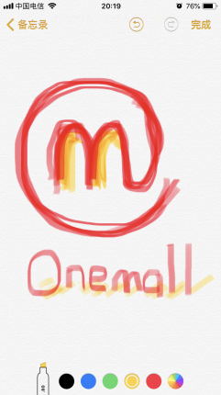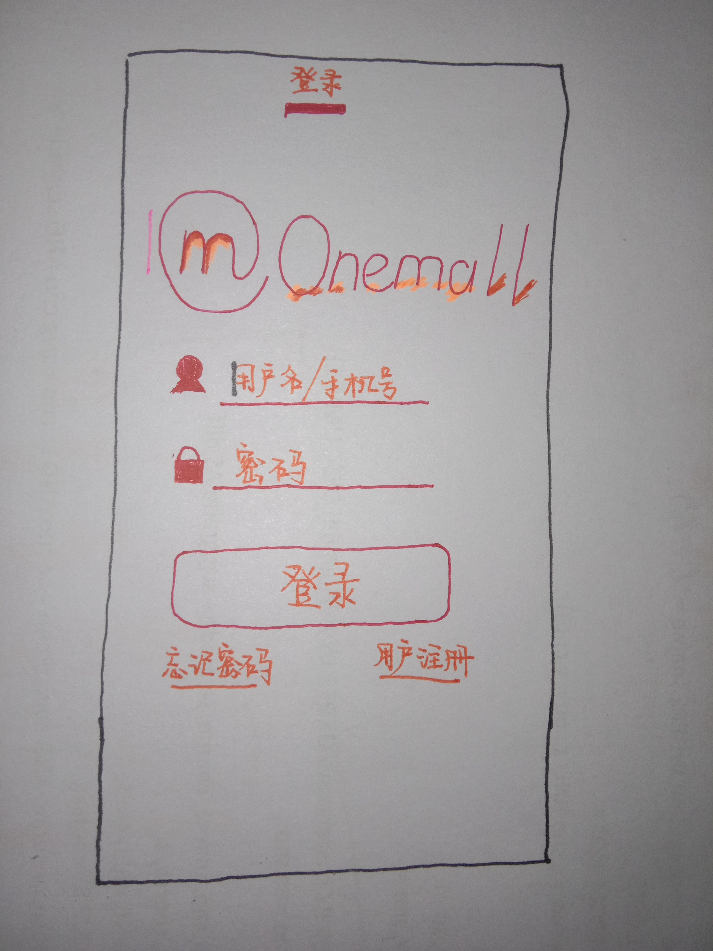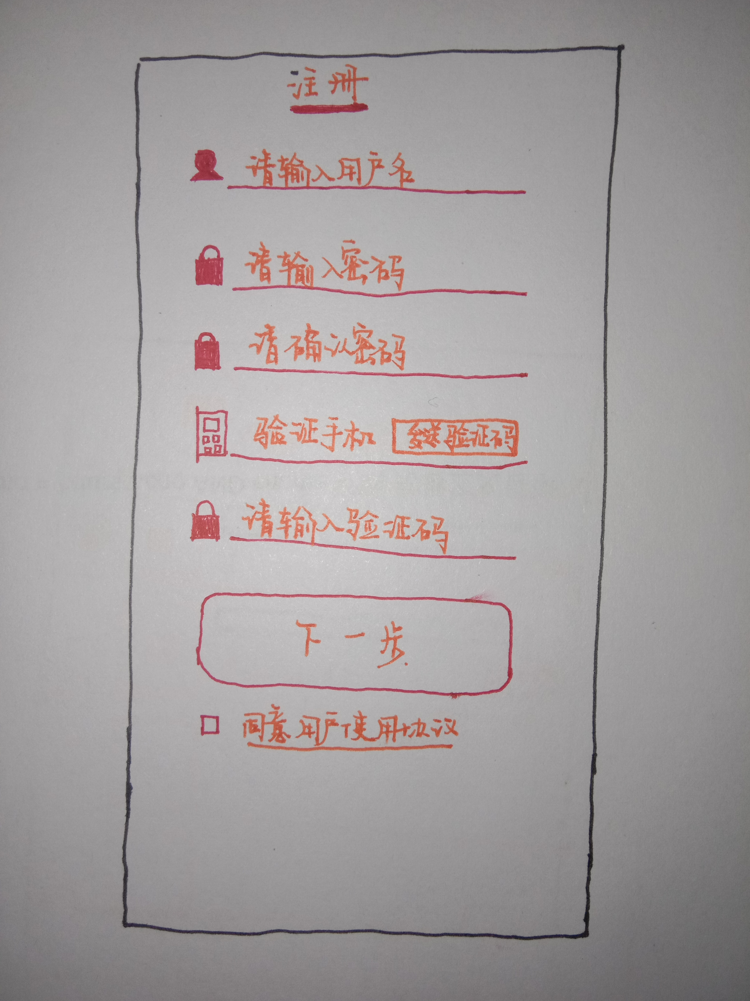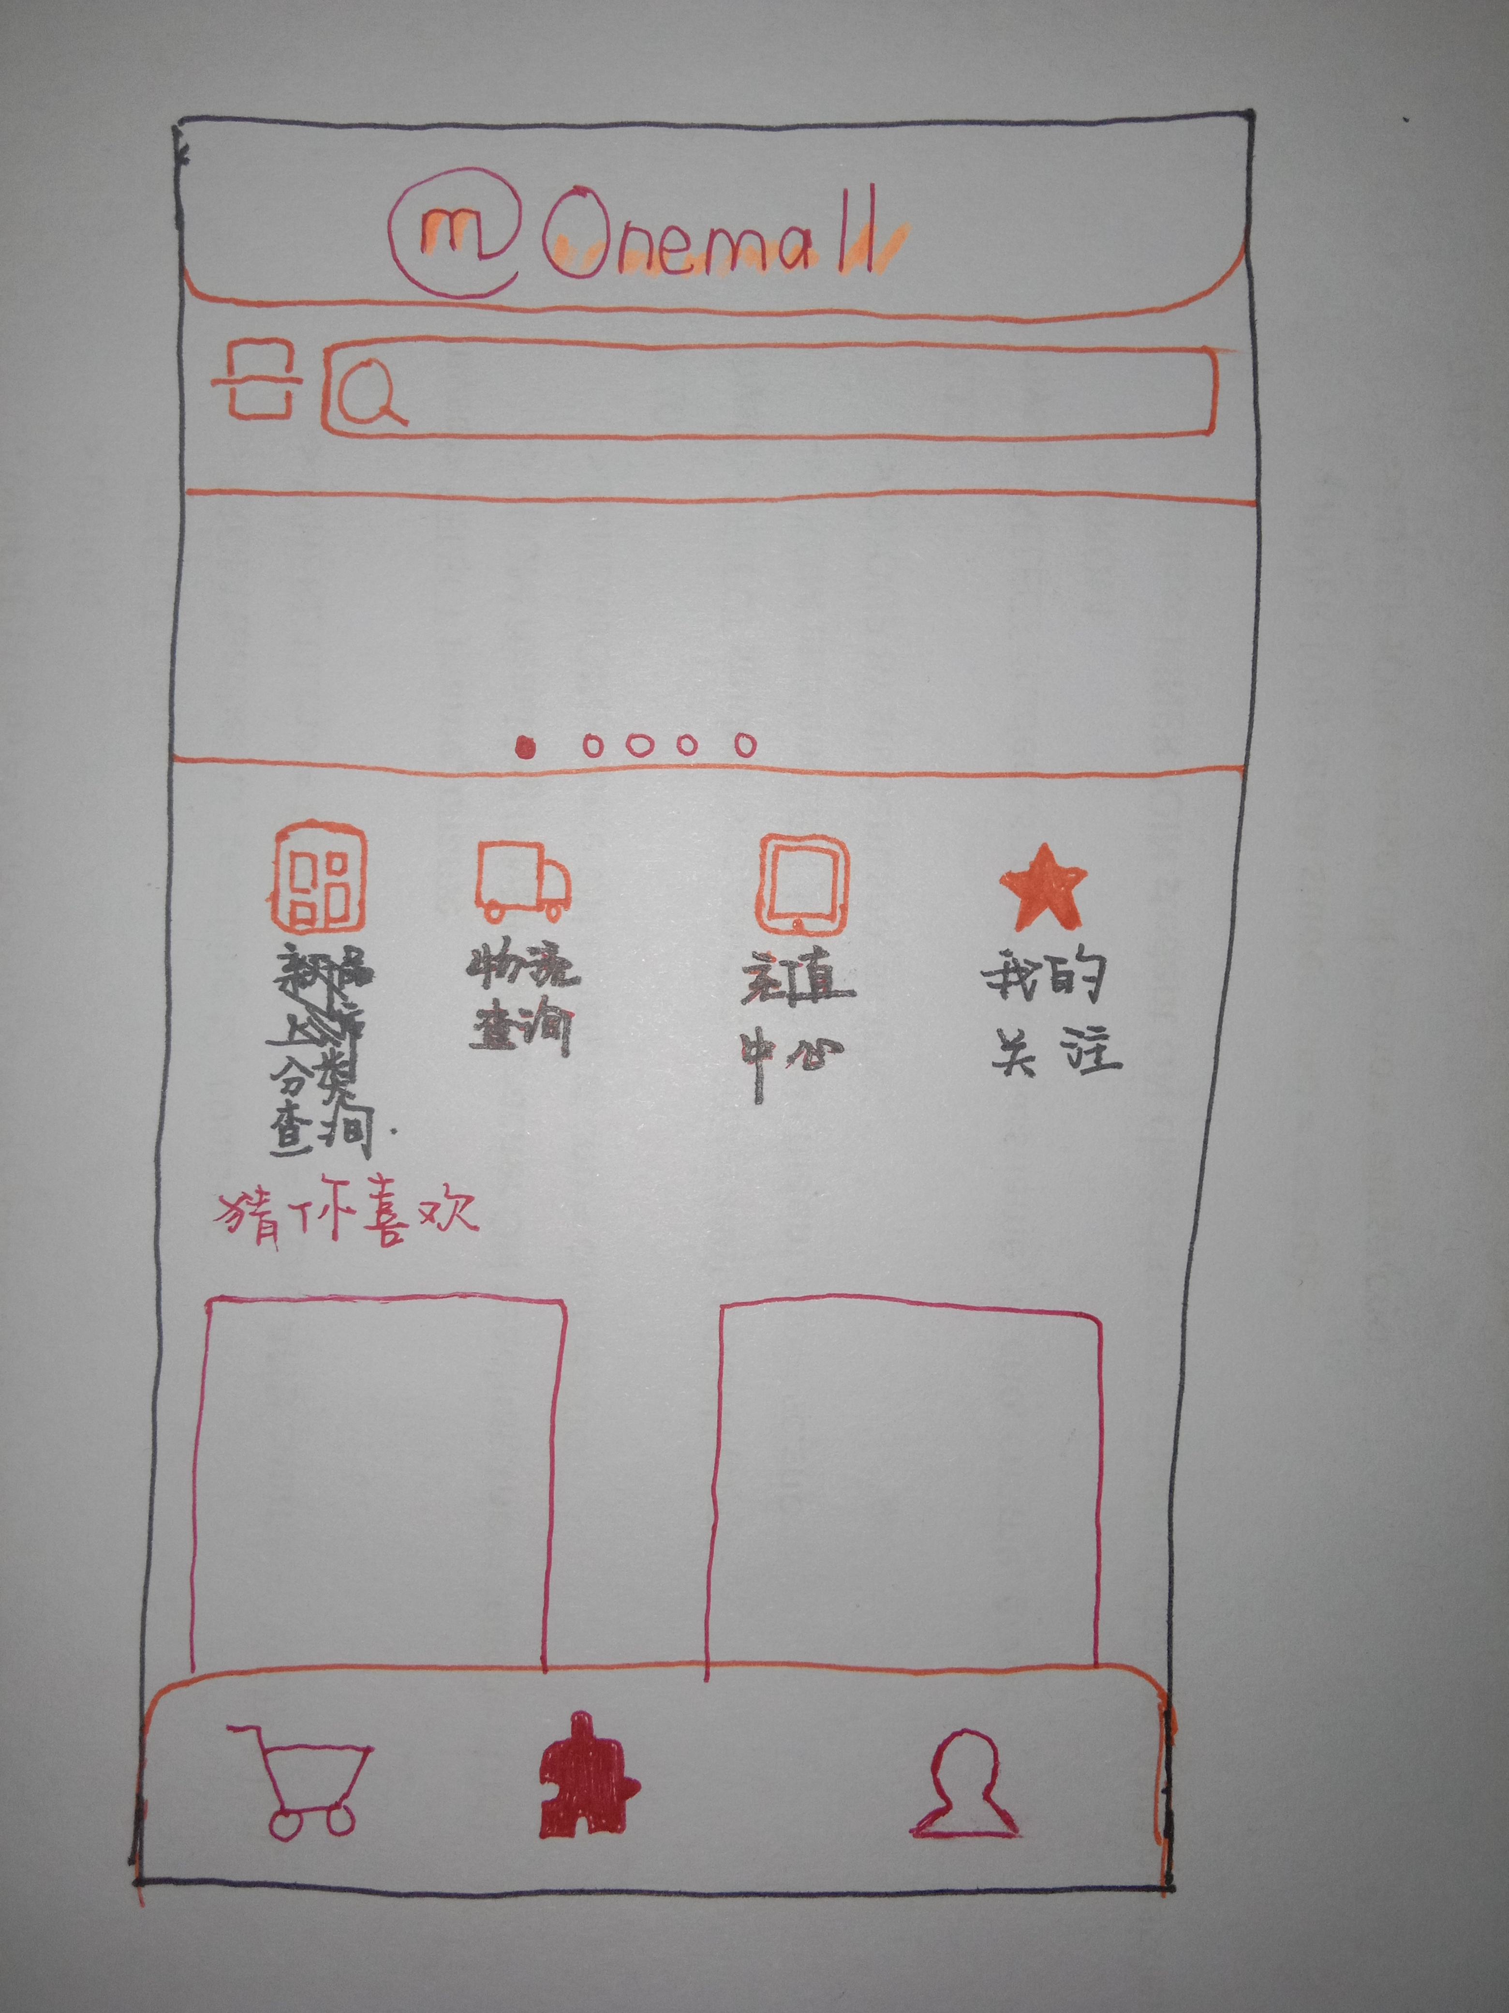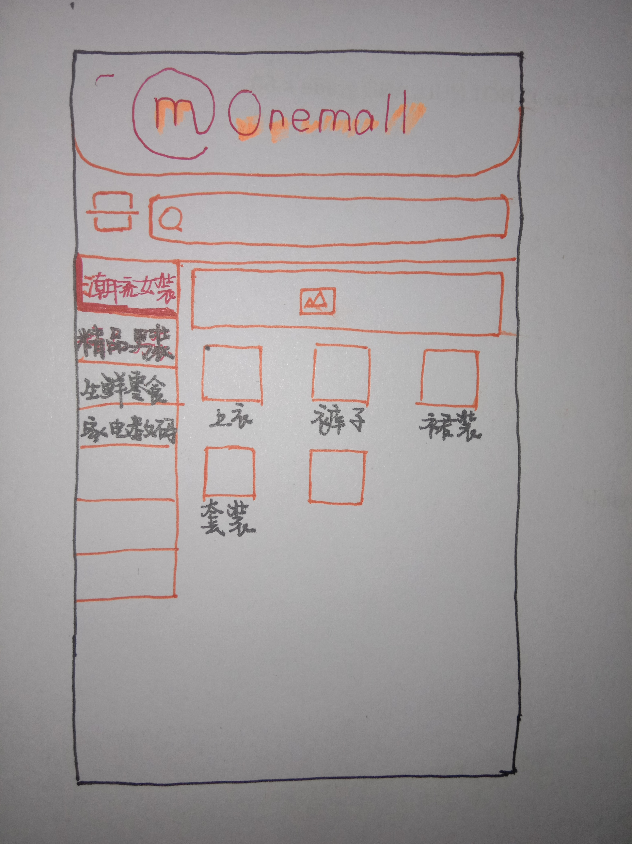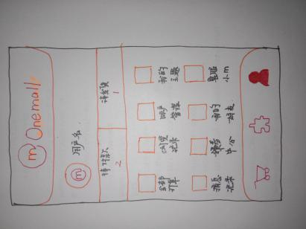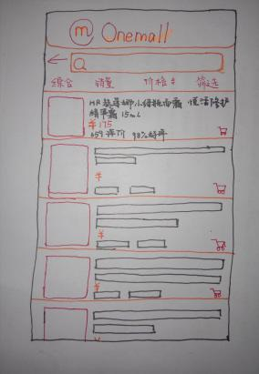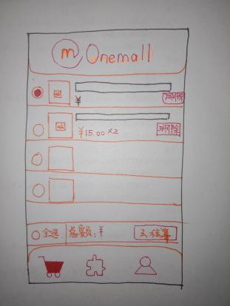

1. **System function narrative**

**Customer module:**

login / registration basic information (user name, password, name, telephone number);

Retrieve the password and modify the password;

Fill in the basic information (name, ID number, bank card number, bound Alipay, receiving address);

Browse goods (commodity price, merchant, shipping address, purchase quantity, purchase record, view user comments);

Shopping cart (add goods, delete goods, pay, pre-purchase);

User center: account management (add friends, delete friends, change login accounts);

Coupons, the use of points balance;

Ship-to-address management (new address, delete address, modified address);

a collection of goods/ stores;

Product recommendation/ guess you like;

Order management: pending payment: create order, cancel order, order payment;

To be received: confirm receipt;

To be evaluated: evaluate shops and commodities;

After-sale: check the order, delete the order, another order, apply for a refund, again evaluation;

History browsing;

Contact customer service;

**Merchant module:**

log in / register store information (store name, password, person in charge name, telephone number);

Fill in the shop information (shop location, category, person in charge ID card number, bank card number, bound Alipay);

Add goods (commodity price, inventory, sales record);

Modify goods (price, inventory);

Order processing (delivery, refund);

processing the after-sales information of the user;

Contact the Buyer;

Promotion management( Promotion tools, Marketing template, Interactive marketing);

[计] data management

Industry / store data analysis (commodity sales ranking, volume analysis, promotion effect analysis, regional analysis, etc.)

Order Management( Order processing , Purchase and sale storage , Order analysis);

customer management (Member marketing ,Member management, customer analysis).